The TrustX Transparency Train Is Picking Up Speed
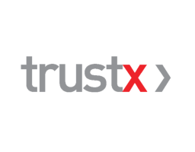
Of the 35 publishers that have committed themselves to trying TrustX, 16 are actively trading, including Hearst, NBCU, CBS Interactive, The Washington Post, New York magazine, Univision, Viacom, A+E and The Atlantic. Kohl expects four more publishers in the pipeline to make their inventory available by the end of the year.
AdExchanger 11.28.17
https://adexchanger.com/online-advertising/trustx-transparency-train-picking-speed-next-stop-trade-desk/?utm_source=API+Need+to+Know+newsletter&utm_campaign=d77ae816d2-EMAIL_CAMPAIGN_2017_11_29&utm_medium=email&utm_term=0_e3bf78af04-d77ae816d2-31697553

