These Models Make Their Real Money On Instagram
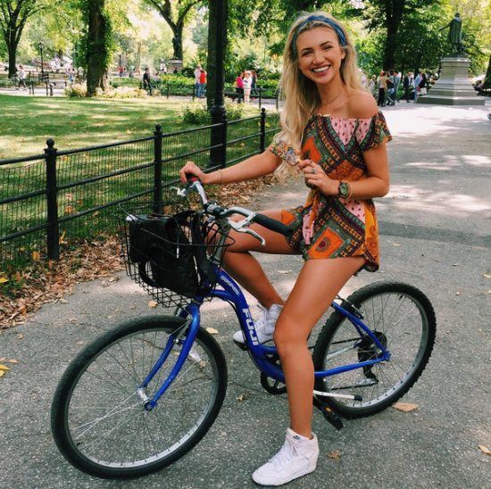
Some models apparently are making more money on Instagram than they would doing traditional work. Gabrielle Epstein, a former Miss Universe Australia with nearly 700,000 Instagram followers, says product-placement deals let her make hundreds of dollars per post and thousands of dollars for extended campaigns on the platform.
Gold Coast Bulletin (Australia) 10/3/15
http://www.goldcoastbulletin.com.au/lifestyle/insta-famous-gold-coast-girls-share-their-secrets-to-making-money-via-social-media/story-fnj94iqm-1227554645569

