This Colorado Middle School Banned Phones 7 Years Ago
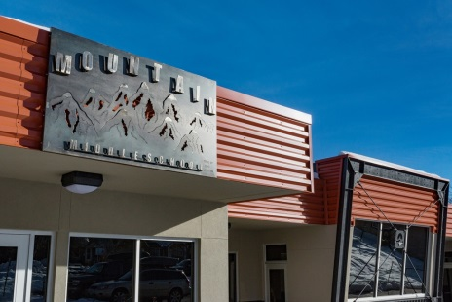
“What we've tried to do at our school is create a safe zone,” said Shane Voss, Head of School at Mountain Middle School. “The eight hours of a school day when students don't have to worry about that added extra pressure.” He calls it a sanctuary. “They can just be a kid for eight hours and not have to worry about all the madness of responding and playing that digital game with their friends.”
Colorado Public Radio News 11.5.19
https://www.cpr.org/2019/11/05/this-colorado-middle-school-banned-phones-seven-years-ago-they-say-students-are-happier-less-stressed-and-more-focused/
Image credit:
http://preview.fciol.com/wp-content/uploads/2017/03/3511_8876-1024x683.jpg

