Niki Caro, Ava DuVernay, Anna Boden Make History Directing $100M Films
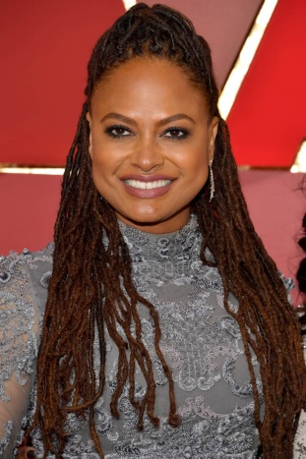
"A Wrinkle in Time" director Ava DuVernay, "Captain Marvel" director Anna Boden and "Mulan" director Niki Caro are responsible for the most-anticipated films with budgets over $100 million, marking the first time in film history that more than one woman has managed a $100 million budget at one time. "Not only are we all making these movies at the same time, but they're all at the same studio. I feel proud taking these pictures with them here [on the Disney lot]," DuVernay said.
The Hollywood Reporter 12/6/17
https://www.hollywoodreporter.com/news/disneys-new-100m-club-female-directors-pose-group-photo-1063697
Image credit:
http://photos.laineygossip.com/articles/ava-duvernay-oscars-27feb17-04.jpg

