Three Women’s Newsletters on the Decline of the Glossy Magazine
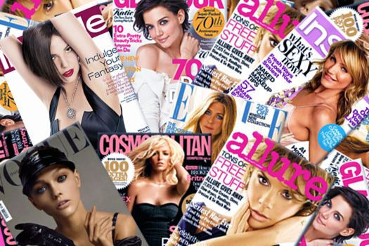
With the folding of More and Lucky magazines, layoffs across properties, and more brands focusing their marketing efforts on mobile and digital, it’s not a golden age for women’s magazines in print. One place at least some of the audience’s attention is moving: email newsletters. With 55 percent of email opens happening on phones, it’s an increasingly powerful way to reach readers directly on mobile.
Nieman Lab 8.18.16
http://www.niemanlab.org/2016/08/its-a-little-bit-of-a-crazy-concept-three-womens-newsletters-on-the-decline-of-the-glossy-magazine/?utm_source=API+Need+to+Know+newsletter&utm_campaign=a7502f66f9-Need_to_Know_August_19_20168_19_2016&utm_medium=email&utm_term=0_e3bf78af04-a7502f66f9-31697553

