TikTok Vies With YouTube For Kid Audience
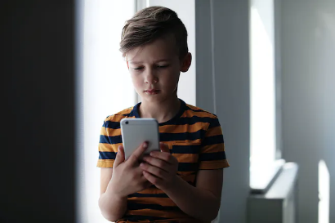
Among children between 2 and 12 years old, 84% watch YouTube, PreciseTV reports. The study also found that 34% had recently viewed TikTok videos, nearly reaching the combined total of Snapchat, Instagram and Facebook, and TikTok has inspired 31% of purchase requests.
Next TV/Broadcasting+Cable 1.18.23
https://www.nexttv.com/news/tiktok-gaining-on-youtube-as-key-way-to-reach-kids?utm_term=A25693A1-51B6-4112-BDE4-56BD420E983F&utm_campaign=46D8BE3E-0142-457E-B195-A1325C099C61&utm_medium=email&utm_content=0A8CD89A-4CC3-46BA-8B3F-13F9EB606A1C&utm_source=SmartBrief
image credit:
https://images.prismic.io/netmums/180fb4bc-da77-4b7e-8ed4-636868e4e02a_tiktok.jpg?auto=compress,format&rect=0,0,1500,1000&w=660&h=440

