TikTok, Reddit Better at Clamping Down on Hate Speech
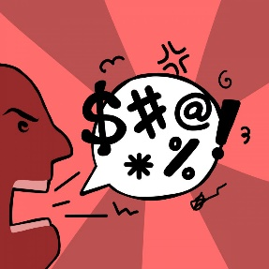
Reddit and Chinese-owned TikTok made more significant strides during the second half of 2020 in combating hate speech and the spread of misinformation than larger competitors, including Facebook, Twitter and YouTube, according to an IPG Mediabrands audit. IPG Mediabrands reviewed nine social platforms and pointed to TikTok, which made the biggest strides, for its brand safety partnerships and consumer controls.
Reuters 2.8.21
https://www.reuters.com/article/social-media-advertising-safety/facebook-twitter-among-platforms-failing-to-prevent-harmful-content-agency-idUSL1N2KC01P
Image credit:
https://snworksceo.imgix.net/pri/9ad064b1-f9ea-4583-84df-4b055befb3ed.sized-1000x1000.png

