Tips to Make Ethics A No-Brainer
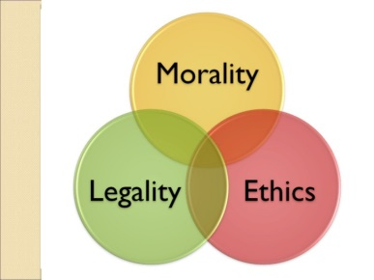
Ethical dilemmas are common in the daily lives of PR professionals, but if they always aspire to do what's right, wise decision-making is easy, writes Michele E. Ewing, APR, Fellow PRSA. To integrate ethics regularly, Ewing shares insight from PRSA's Board of Ethics and Professional Standards members and urges communication pros to think about ethics from various standpoints, discuss issues with colleagues throughout the organization and apply PRSA's Code of Ethics and other models.
PRSAY 9/4/19
https://prsay.prsa.org/2019/09/04/ethics-month-2019-a-celebration-of-ethics-every-day/
Image credit:
https://image.slidesharecdn.com/ethics-and-communication-in-pr-1219618852827277-9/95/the-ethical-public-relations-practitioner-4-728.jpg?cb=1233681937

