TiVo to Launch Live TV Apps for Fire, Apple, Roku
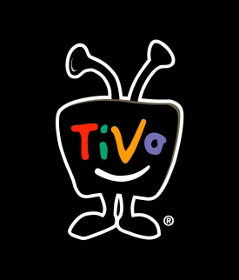
TiVo is rolling out apps that will allow Apple TV, Roku and Fire TV customers to stream content without having to purchase TiVo Minis. The apps are expected to launch later in 2019, and they will be part of TiVo's continuing effort to reach cord cutters.
The Verge 1/9/19
https://www.theverge.com/2019/1/9/18175793/tivo-dvr-apple-tv-roku-fire-tv-live-recorded-streaming-video-apps-cord-cutters-ces-2019

