T-Mobile: 6-Second Series Spots A Home Run
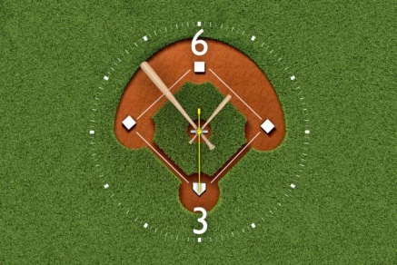
T-Mobile, which last month used the six-second format to promote its hurricane relief efforts during Fox's coverage of the World Series, said results suggest that the short-form spots boosted viewer engagement metrics such as brand recall, likability and message recall.
Advertising Age 11.21.17
http://adage.com/article/media/tmobile-six-second-ads-world-series/311361/
Image credit:
http://gaia.adage.com/images/bin/image/x-large/baseballclock2.jpg

