T-Mobile Just Made Watching Sports Even Easier
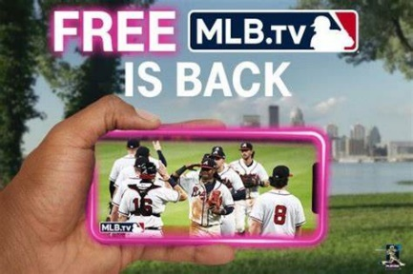
For the ninth-consecutive Major League Baseball season, T-Mobile is offering customers a pro baseball season's worth of free access to MLB.TV. The wireless company is also rolling out a new product feature called "Secret Baseball Button," a bluetooth-enabled tool that allows office workers and other customers constrained by "The Man" to watch baseball on the job without risk of being caught by their boss.
Next TV 4.1.24
https://www.nexttv.com/news/t-mobile-just-made-watching-sports-and-slacking-off-even-easier?utm_term=A25693A1-51B6-4112-BDE4-56BD420E983F&lrh=118ef759fa30c9f241e56a8fad187fca3c60b618fcbe1c6663d5bdf5bf126316&utm_campaign=C74FC4FA-5D4D-4151-8915-3043BA411DBE&utm_medium=email&utm_content=2C97ADC7-5F96-4B5F-8022-DC9B9F1CDD9C&utm_source=SmartBrief
Image copyright:
https://m-cdn.phonearena.com/images/article/130144-two_940/T-Mobiles-free-MLB.TV-deal-is-back-in-2021.jpg

