T-Mobile Signs $26B Deal to Purchase Sprint
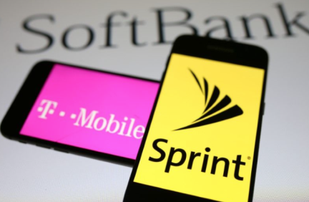
T-Mobile has agreed to purchase Sprint in a $26 billion all-stock deal that is expected to undergo regulatory scrutiny. Executives from both companies say the deal, which would put T-Mobile CEO John Legere in charge of the combined company, would help speed up the arrival of 5G.
Axios 4/29/18
https://www.axios.com/t-mobile-sprint-ceos-make-case-for-deal-1525019481-c6287927-87f5-4ff2-b838-b9a62ee37c80.html
Image credit:
https://seekingalpha.com/article/4162356-sprint-another-merger-head-fake

