Facebook, Microsoft, Twitter, YouTube Unite to Tackle Extremist Content
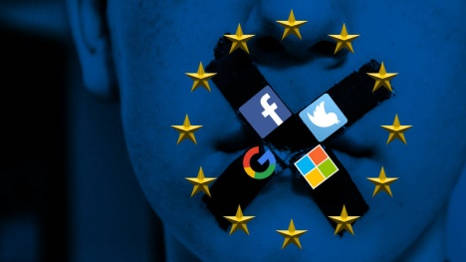
Facebook, Microsoft, Twitter and YouTube have teamed up to create a worldwide working group focused on eliminating extremist content from their platforms. The four companies will collaborate on a shared database that tracks digital fingerprints associated with extremist videos and images; they will also share best practices on using machine learning to combat extremist content.
Reuters 6/26/17
http://www.reuters.com/article/us-internet-extremism-idUSKBN19H20A
image credit:
https://rdice.net/a/c/n/16/EU-PC.ab94b306.jpg

