Tobacco is Appearing More in Blockbuster Movies
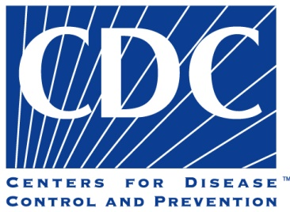
Depictions or suggestions of tobacco use in top-grossing movies rose 72 percent from 2010 to 2016, according to the report, published by the Centers for Disease Control and Prevention. The increase was especially large among top-grossing movies with R ratings, which saw a 90 percent rise in tobacco-use imagery, though researchers noted with special concern that movies rated PG-13 also saw a sizable increase: 43 percent.
The New York Times 7.11.17
https://www.nytimes.com/2017/07/11/us/tobacco-movies-study.html?rref=collection%2Fsectioncollection%2Fbusiness-media&action=click&contentCollection=media&region=stream&module=stream_unit&version=latest&contentPlacement=3&pgtype=sectionfront

