Too Much TV Affects Low-Income Kids More
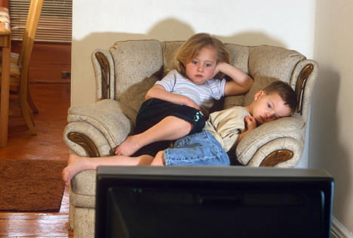
The study, published in the Journal of Developmental and Behavioral Pediatrics, looked at 807 kindergartners from a variety of backgrounds. The findings? The numbers of hours of TV kids watch correlates to a decrease in school readiness, specifically in math skills. While the study did find a correlation between TV viewing and math skills, there was no similar link found with knowledge of letters and words.
MediaLife 3.8.17
http://www.medialifemagazine.com/much-tv-affects-low-income-kids/
Image source:
http://hothardware.com/newsimages/Item15043/kids-tv.jpg

