Tractor Supply Upgrades Loyalty Program, User Experience
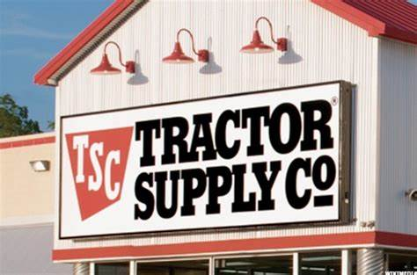
Tractor Supply is upgrading its Neighbor's Club loyalty program with more benefits and a lower earnings tier, with plans to add a benefit for active military, veterans and first responders in the summer. The retailer is also using large language models and AI to offer customers personalized recommendations based on purchases, part of its effort to gain more first-party data on customers' needs.
Retail Info Systems News 3.5.24
https://risnews.com/tractor-supply-launches-loyalty-program-enhancements-gets-more-targeted-personalization

