Trade Groups to Congress: Say No to Net Neutrality
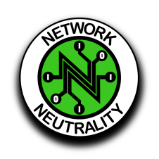
The CEOs of NCTA-The Internet & Television Association, USTelecom and CTIA in a letter to Sens. Mitch McConnell, R-Ky., and Chuck Schumer, D-N.Y., cautioned against voting for the Congressional Review Act resolution to nullify the Federal Communications Commission's rollback of net neutrality rules. Reversing the Restoring Internet Freedom order would hinder infrastructure improvements and investment aimed at improving rural broadband connectivity, the groups wrote.
Broadcasting & Cable 5/15/18
https://www.broadcastingcable.com/news/isps-on-net-neutrality-cra-no-way

