Triller Entices Brands With Influencer, Content Services
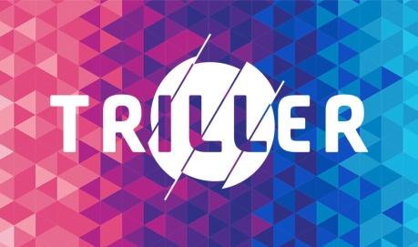
Triller is positioning itself as a TikTok alternative, emphasizing brand safety and launching Crosshype to help companies connect with influencers. The short-form video app is also readying a Brand Lab to assist with content creation.
The Drum (free registration) 10/21/20
https://www.thedrum.com/news/2020/10/21/triller-pitching-its-wares-brands-can-it-grow-tiktok-killer

