Trump Blamed for Decline in U.S. Standing in Press-Freedom Survey
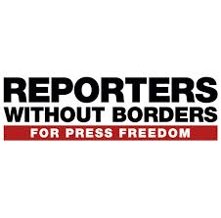
The watchdog organization Reporters Without Borders on Wednesday released its annual World Press Freedom Index, which ranks 180 countries from highest to lowest levels of press freedom. The United States fell in the ranking, as it did last year — this time, two places down to 45th. Norway remained on top, with North Korea as its polar opposite.
The Washington Post 4.25.18
https://www.washingtonpost.com/lifestyle/style/trumps-attacks-on-media-blamed-for-decline-in-us-standing-in-press-freedom-survey/2018/04/25/7c940722-48a7-11e8-8b5a-3b1697adcc2a_story.html?utm_term=.778dd7d37448

