Trump's "Fake News" Being Used to Control Press Worldwide
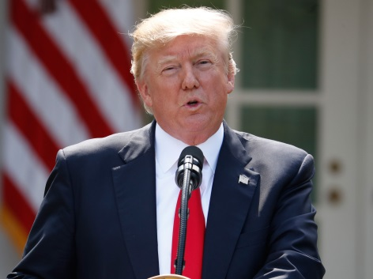
A Politico report has found that major leaders in at least 15 countries are using President Donald Trump's "fake news" line to speak out against their critics, with the Committee to Protect Journalists' Joel Simon calling the move a tactic to shield "their attacks on press freedom and human rights."
Politico 12/8/17
https://www.politico.com/story/2017/12/08/trump-fake-news-despots-287129
Image credit:
https://static.independent.co.uk/s3fs-public/thumbnails/image/2017/06/01/20/donald-trump-paris.jpg

