Turkey's Crackdown on its Media Goes Into Overdrive
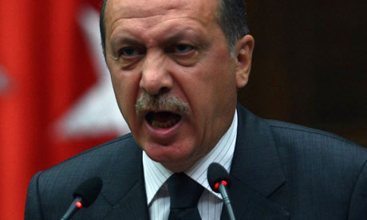
During Turkey’s current three-month state of emergency the government has ordered the closure of 102 media outlets, including 45 newspapers, 16 TV channels, three news agencies, 23 radio stations, 15 magazines and 29 publishing houses. The Turkish governments insists these measures are justified for security reasons and says journalists currently in jail are being investigated or prosecuted for possible criminal activities.
The Guardian 8.29.16
https://www.theguardian.com/world/2016/aug/29/stop-the-press-turkey-crackdown-journalists-overdrive-since-coup?utm_source=API+Need+to+Know+newsletter&utm_campaign=75cf096715-Need_to_Know_August_30_20168_30_2016&utm_medium=email&utm_term=0_e3bf78af04-75cf096715-31697553

