Turkish Journalists Under Severe Pressure
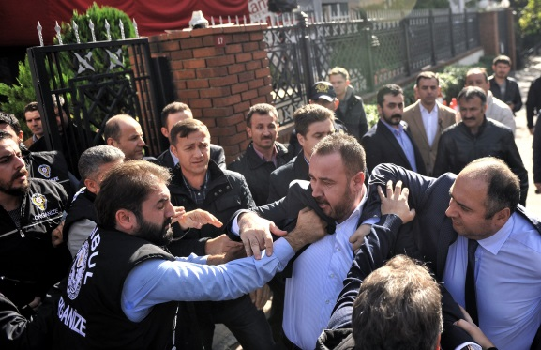
Pressure on journalists in Turkey has severely escalated since parliamentary elections on June 7, restricting the media's ability to report on matters of public interest, according to press freedom groups who conducted a joint international emergency mission to the country. The group said that if the pressure continues, it is likely "to have a significant, negative impact on the ability of voters in Turkey to share and receive necessary information, with a corresponding effect on Turkey's democracy."
Committee to Protect Journalists 10/30/15
https://cpj.org/blog/2015/10/joint-mission-finds-turkish-journalists-under-seve.php?utm_source=API%27s+Need+to+Know+newsletter&utm_campaign=b64abaf0c0-Need_to_Know_October_30_201510_30_2015&utm_medium=email&utm_term=0_e3bf78af04-b64abaf0c0-31697553

