Turner Broadcasting Plans More Content for Snapchat
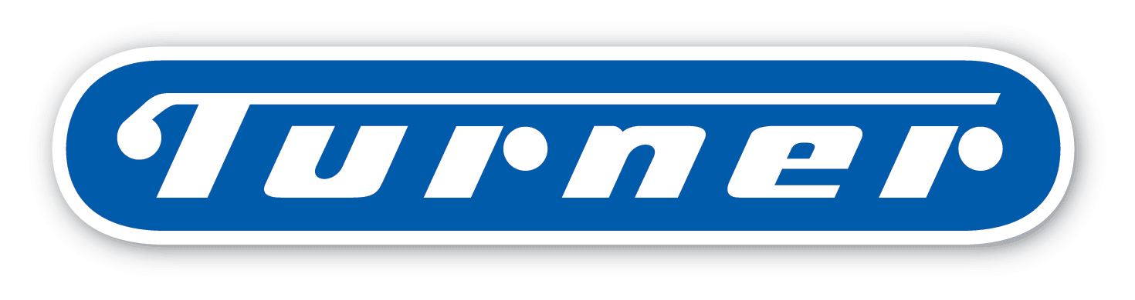
Turner Broadcasting System said it plans to increase the amount of video content it provides to Snapchat and that the companies will cooperate on advertising. Snapchat is strengthening partnerships with major US media companies as it gets ready for an initial public offering.
Reuters 12/7/16
http://www.reuters.com/article/us-snapchat-time-warner-advertising-idUSKBN13W2OD

