Turner set to go SVOD
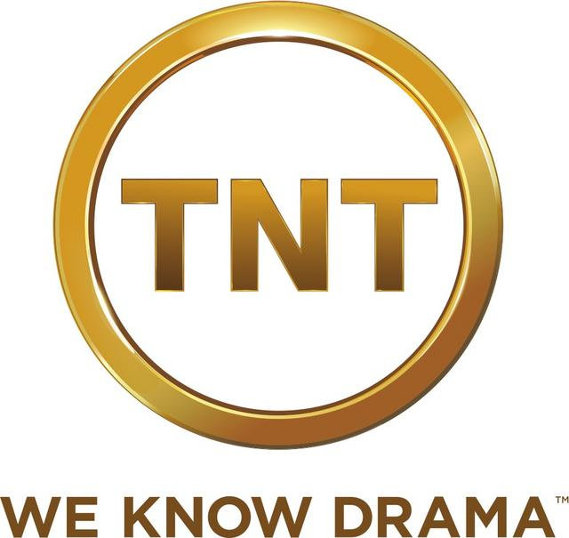
Turner Networks is getting set to deliver a direct-to-consumer OTT offering. "Cable has done a poor job marketing how good $80 is, what you get for that $80." "So, we as a company have to find ways to find new revenue streams, whether in new pockets, sports, over-the-top, direct to consumer, “said Turner President Dave Levy,
Fierce Cable 11/23/15
http://www.fiercecable.com/story/turner-set-go-svod-group-president-says/2015-11-23

