GLAAD: TV Boasts Record Number of LGBTQ Characters
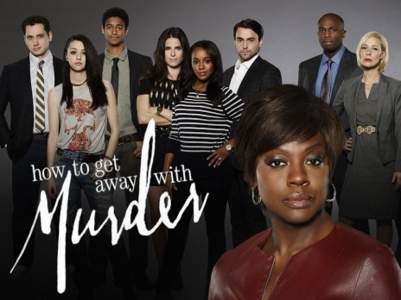
According to GLAAD's "Where We are on TV 2018" report, for the first time broadcast TV has a balance of male and female LGBTQ characters, which includes a record 75 regular characters. For cable networks, FX has the highest number of LGBTQ characters, while Netflix tops streaming services.
Variety 10/25/18
https://variety.com/2018/tv/news/glaad-where-we-are-on-tv-2018-report-record-high-representation-1202990364/
Image credit:
https://www.fasdapsicanalise.com.br/content/uploads/2016/06/how_to_get_away_with_murder.jpg

