TV Diversity Hits Record Highs Onscreen in 2016-17 Season
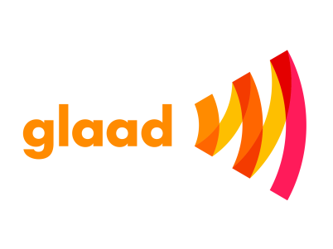
The “Where We Are on TV” report by GLAAD found that 4.8% of all broadcast series-regular characters expected to appear in the coming season are LGBTQ — the highest percentage in study’s 21-year history. Black characters accounted for 20% of all broadcast series regulars, and characters with disabilities for 1.7% — both also all-time highs.
Variety 11.3.16
http://variety.com/2016/tv/news/tv-diversity-record-highs-glaad-1201907668/

