TV Offers Educational Lifeline to "Digital Have-Nots"
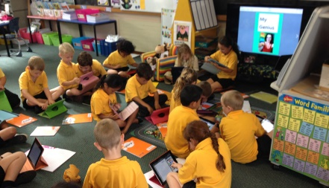
Families who lack broadband internet access at home are turning to television to access education for their children as the pandemic continues to disrupt traditional school schedules. Industry experts are touting the rise of NextGen TV as a potential game-changer for closing the digital divide.
TV Technology 9.9.20
https://www.tvtechnology.com/opinion/tv-as-a-teacher
Image credit:
https://trabasack.com/wp-content/uploads/2017/06/Demoing-with-Apple-TV.jpg

