Twitter Bans All Political Advertisements
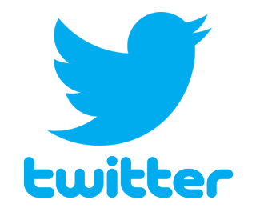
The social media service's CEO Jack Dorsey says: "While internet advertising is incredibly powerful and very effective for commercial advertisers, that power brings significant risks to politics, where it can be used to influence votes to affect the lives of millions."
TVNewsCheck 10.30.19
https://tvnewscheck.com/article/top-news/240672/twitter-bans-all-political-advertisements/?utm_source=Listrak&utm_medium=Email&utm_term=Twitter+Bans+All+Political+Advertisements&utm_campaign=Syndies+Still+A+Big+Draw+For+Viewers+%26+Advertisers

