Twitter Crafts Plan to Combat "Deepfake" Content
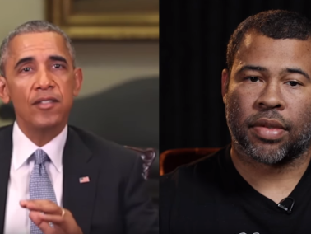
Twitter has designed a draft proposal to combat nefarious content that's "synthetic or manipulated ... that's intentionally trying to mislead or confuse people," according to a company blog post, and is welcoming comments through Nov. 27 via an online survey and #TwitterPolicyFeedback. Plans include placing notices next to suspected tweets, warning individuals before sharing content and adding links to sources.
TechCrunch 11/11/19
https://techcrunch.com/2019/11/11/twitter-drafts-a-deepfake-policy-that-would-label-and-warn-but-not-remove-manipulated-media/?renderMode=ie11
Image credit:
https://www.pressgazette.co.uk/wp-content/uploads/2018/11/Obama-Peele-e1542306751331.png

