Twitter Launches Features to Filter Out Abuse
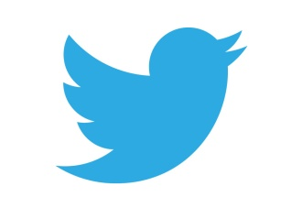
Twitter has responded to complaints about abuse on the platform by introducing features such as a quality filter, and letting users limit their notifications to followers only. The quality filter factors in user behavior and the length of time accounts have been active.
Marketing Land 8/18/16
http://marketingland.com/twitter-quality-filter-notification-188610

