Twitter Gets Streaming Rights for NFL Games
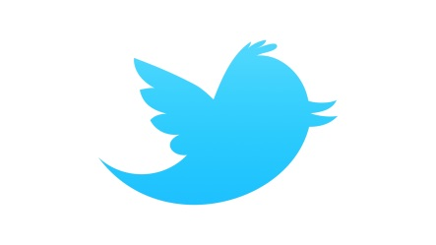
Twitter has edged out online rivals, including Facebook and Amazon, and gained the right to stream Thursday night NFL games. The league sees the deal as a way of reaching young users who don't have cable subscriptions and chose Twitter over others willing to pay more because of the social network's reach.
The New York Times 4/5/16
http://www.nytimes.com/2016/04/06/sports/football/nfl-will-stream-thursday-games-on-twitter.html?WT.mc_id=SmartBriefs-Newsletter&WT.mc_ev=click&ad-keywords=smartbriefsnl&_r=0

