Twitter's Subscription Plans Taking Shape
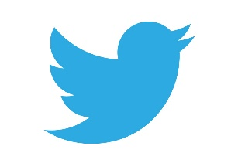
Twitter is developing Twitter Blue, a subscription service with features such as undo and saved tweet functions that will likely cost users $2.99 a month, and may include pricing tiers that could include an ad-free option, according to app researcher and tipster Jane Manchun Wong. The social platform also will reportedly relaunch its verification program this week.
TechRadar 5/16/21
https://www.techradar.com/news/twitter-subscription-service-leaks-reveal-name-price-and-an-undo-tweet-option?utm_source=SmartBrief&utm_medium=email&utm_campaign=40A39351-5419-4681-94DF-31A53480B698&utm_content=975DB3CF-5499-46EF-AC30-3B012472423E

