Twitter Promotes Second Live Concert with New Features
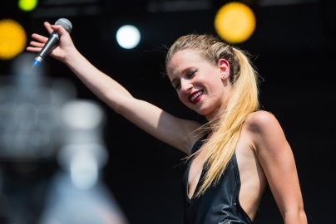
Twitter live-streamed its second concert in partnership with Live Nation on Tuesday night with new promotional features. Twitter marketed the Marian Hill concert, sponsored by T-Mobile, with ads that included a reminder button for users to press to get a push notification when the live stream started and a branded timeline that pulled all social chatter about the event into one place.
Adweek 5/30/17
Image credit:
http://www.rbeatz.com/wp-content/uploads/2016/02/21925468369_8cf0191911_b.jpg

