Twitter to Explore New Social Media Platform Model
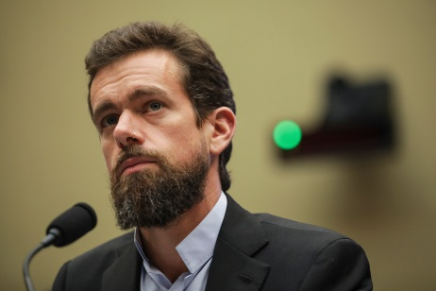
Twitter CEO Jack Dorsey plans to create an independent team, dubbed Bluesky, to assess the feasibility of an "open and decentralized standard for social media" -- a model that could run on blockchain and enable collaborative new approaches to algorithm recommendations, content moderation and systems to combat misinformation. The project "is about exploring the fullest and most participatory vision of our service," a Twitter representative said.
Social Media Today 12/12/19
https://www.socialmediatoday.com/news/twitter-will-set-up-a-new-team-to-explore-a-decentralized-social-media-netw/568907/
Image credit:
https://thenypost.files.wordpress.com/2018/09/jack-dorsey.jpg?quality=90&strip=all&w=1200

