Twitter Tops 4Q Local TV Social Media Actions
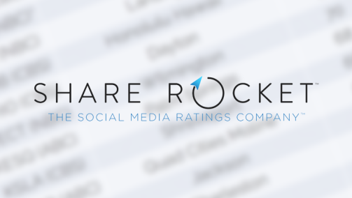
In markets both big and small, tweets still made up the majority of social media posts for local TV broadcasters in the fourth quarter of 2016 despite Facebook’s huge advantages in both audience size and ability to drive engagement on social media, according to Share Rocket data.
Share Rocket 4.6.17
http://sharerocket.com/share-rocket-4th-quarter-market-data/

