Two Local TV journalists Killed Covering Southeast Storm
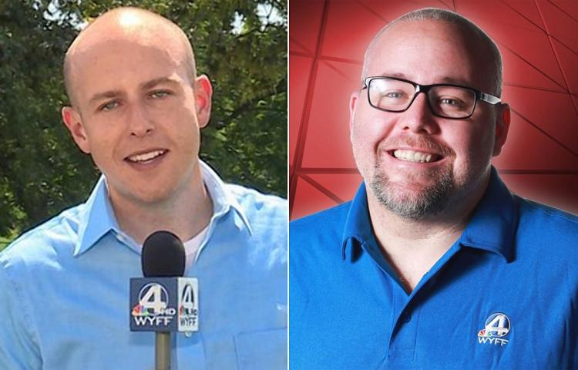
Alberto, the first named Atlantic storm of 2018, made landfall on the Florida Panhandle on Monday and is a subtropical depression that poses a flooding threat throughout the Southeast. Two journalists with an NBC affiliate died in Polk County, N.C., on Monday when a tree fell on their vehicle while they were covering the storm.
CNN 5/28/18
http://money.cnn.com/2018/05/28/media/wyff-mike-mccormick-aaron-smeltzer/index.html
Image credit:
http://assets.nydailynews.com/polopoly_fs/1.4014214.1527552309!/img/httpImage/image.jpg_gen/derivatives/article_750/tree29n-1-web.jpg

