UN Women Teams with Media Outlets to Fulfill Goals of 2030 Agenda
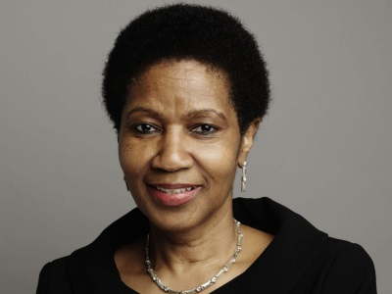
UN Women has announced that it will be partnering with over 35 media outlets for the launch of "Step it Up for Gender Equality Media Compact" aimed at improving the representation and portrayal of women in media. "Even when reporting is entirely factually accurate, if it is reported predominantly by men, about men, it is actually misrepresenting the real state of the world," UN Women Executive Director Phumzile Mlambo-Ngcuka said.
UN News Centre 3/22/16
http://www.un.org/apps/news/story.asp?NewsID=53524#.VvUstE_2b5p

