United Shifts PR Strategy to Highlight Changes
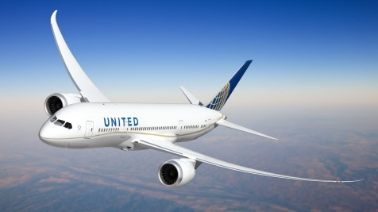
United Airlines has shifted its PR strategy in response to the violent removal of a passenger from one of its flights, launching a multimedia campaign to highlight changes in its overbooking policy. "On a scale of zero to 10, [United's PR response] was in the negative a few weeks ago. Right now, they are probably near a four," North 6th Agency CEO Matt Rizzetta says.
Digiday 4/28/17
https://digiday.com/marketing/united-pr-cleanup/

