University President Threatens Student Newspaper Editor
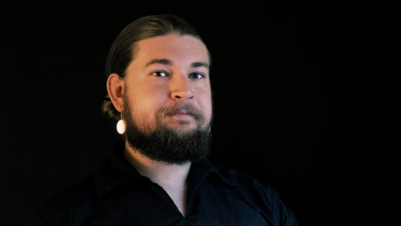
In a meandering, scolding screed that demonstrates shockingly little knowledge of how journalism or the First Amendment work, a public university president formally forbade a student from interviewing government agencies for the student newspaper. He also directed the student editor to start showing university administrators the “highest respect” — or else! HINU President Ronald Graham issued a personally-signed “directive” on Oct. 16 to student journalist Jared Nally.
FIRE 10.26.20
https://www.thefire.org/university-president-threatens-student-newspaper-editor-for-asking-questions-not-treating-administration-with-highest-respect/
Image credit:
https://ogden_images.s3.amazonaws.com/www.ljworld.com/images/2020/10/26133611/Jared-Nally.jpg

