Univision is Buying Gawker Media for $135 Million
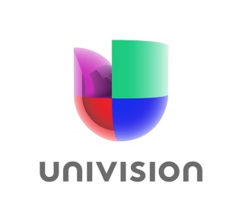
Ziff Davis and Univision were the only two bidders for Gawker, which filed for bankruptcy after Hulk Hogan and Peter Thiel won a $140 million judgment in a privacy case. Ziff Davis had originally offered $90 million for Gawker Media. Univision’s offer will encompass all seven of Gawker Media’s sites, including Gawker.com
ReCode 8.16.16
http://www.recode.net/2016/8/16/12504008/univision-is-buying-gawker-media-for-135-million

