US Homes Average 2.3 TV Sets
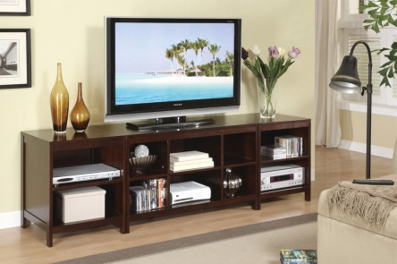
The average number of televisions in US homes dropped to 2.3 in 2015, down from an average of 2.6 in 2009, the Energy Information Administration reports. Alternative devices for TV viewing -- including smartphones, laptops and tablets -- could be contributing to the change.
Recode 7/30/17
https://www.recode.net/2017/7/30/16035706/tv-sets-american-home-decline
Image source:
https://www.huntingtonbeachfurniture.com/content/images/thumbs/0002974_modular-tv-stand-with-storage.jpeg

