US Marketers Up Their Use of Instagram, Snapchat
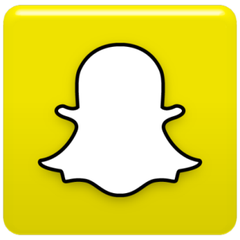
US-based marketers are expanding their use of social media tools, with 28.3% using Snapchat this year, versus 25% in 2017, and 69.2% using Instagram, up from 62.6% last year, eMarketer reports. EMarketer principal analyst Debra Aho Williamson explains that Instagram's popularity stems from advertisers being able to use the platform for organic engagement, while Snapchat primarily encourages paid advertising.
eMarketer 12/13/18
https://www.emarketer.com/content/how-many-marketers-use-instagram-and-snapchat-in-the-us

