US Mobile Gaming Continues Upward Climb
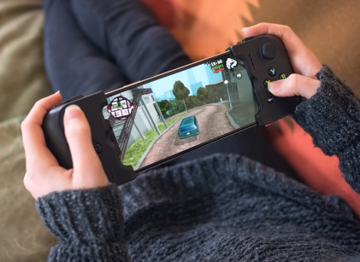
US time spent gaming via mobile app will continue a slow but steady increase in years to come, evidencing gaming's increased popularity is more than just a pandemic phase.
eMarketer 1.19.22
https://www.emarketer.com/content/us-mobile-gaming-upward-climb?ecid=NL1001
Image credit:
https://cdn.player.one/sites/player.one/files/2019/04/01/gamevice-review.jpg

