Verizon Buying AOL for $4.4 Billion
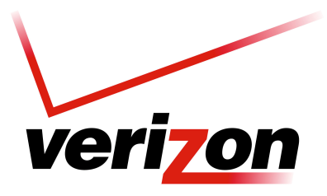
The acquisition gives Verizon an entryway into the increasingly competitive online video space. The New York company is the country's largest wireless carrier as well as an Internet and TV provider, and it is increasingly over the wireless space that telecom companies are fighting to win customers through video content. AOL owns The Huffington Post, TechCrunch, Engadget, MAKERS and AOL.com.
TVNewsCheck 5.12.15
http://www.tvnewscheck.com/article/85271/verizon-buying-aol-for-44-billion?utm_source=Listrak&utm_medium=Email&utm_term=Verizon+Buying+AOL+For+%244.4+Billion&utm_campaign=Verizon+Buying+AOL+For+%244.4+Billion

