Verizon Pays More Than $2B to Livestream NFL Games on Mobile, Digital
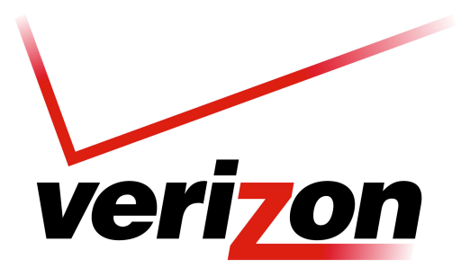
Verizon has reportedly struck a more-than-$2 billion, five-year deal with the NFL to livestream more content and games across digital and mobile networks. The deal includes mobile ad inventory for in-market games.
MediaPost Communications 12/11/17
https://www.mediapost.com/publications/article/311421/verizon-makes-25b-nfl-deal-includes-mobile-stre.html

