Virtual Influencers Become Realistic Marketing Tool
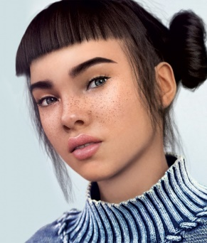
Fashion brands were the first to tap the power of CGI personalities such as Miquela Sousa, who has amassed more than 2.5 million Instagram followers, with more vertical businesses recently jumping on board, including Puma, KFC and the World Health Organization.
The Drum (free registration) 10.1.20
https://www.thedrum.com/opinion/2020/10/01/the-evolution-the-virtual-influencer-no-longer-just-trend
Image credit:
http://biographicsworld.com/wp-content/uploads/2018/07/lil-miquela-the-cut-874x1024.jpg

