Virtual Reality Is Changing Travel Marketing
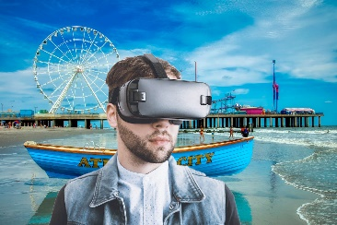
Virtual reality is pushing travel marketing to a whole new level by giving users a real sense of a place. VR is a low-risk way for curious travelers to "try on" a destination and whet their appetites for more.
The Drum (free registration) 1/28/22
https://www.thedrum.com/news/2022/01/28/how-technology-powering-new-generation-travel-marketing
Image credit:
https://yellrobot.com/virtual-reality-in-the-travel-industry-vr/

