Virtual Reality Predictions: What Advertisers Should Know
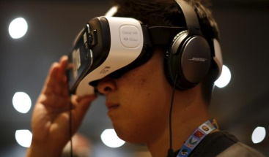
Goldman Sachs has released four charts showing its predictions for virtual reality, including that it will be an $80 billion market by 2025 but will have slower uptake than that seen with mobile devices. Video games will be the largest area to use virtual reality, followed by health care, engineering, live events and video entertainment.
Bloomberg 1/13/16
http://www.bloomberg.com/news/articles/2016-01-13/goldman-sachs-has-four-charts-showing-the-huge-potential-in-virtual-and-augmented-reality

