Vizio Launches Smart TV Advertising Business
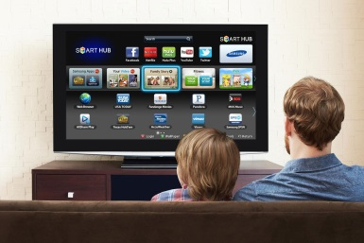
“One of the best ways to improve the TV viewing experience is to improve the state of TV advertising,” said Vizio founder and CEO William Wang, in a statement. “The launch of direct advertising across our TV platform isn’t just good business for us, it’s an investment we’re making to help the industry at large and will benefit the most important part of our business, the viewer at home.”
FierceVideo 12.10.19
https://www.fiercevideo.com/video/vizio-launches-smart-tv-advertising-business?utm_source=Listrak&utm_medium=Email&utm_term=Vizio+Launches+Smart+TV+Advertising+Business&utm_campaign=Vizio+Launches+Smart+TV+Advertising+Business
Image credit:
http://s3.amazonaws.com/digitaltrends-uploads-prod/2015/02/Samsung-Smart-TV-HUB_.jpg

