Voice-Assisted Devices Present Marketing Opportunity
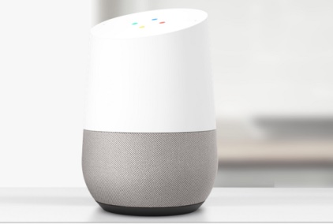
About 67 million voice-assisted devices will be in use in the US by 2019, per eMarketer, and marketing firms are seeking ways to leverage the technology in advertising. NPR is an early adopter, using machine learning to tailor listener experiences through its partnership with Amazon's Alexa.
Adweek 8/7/17
http://www.adweek.com/digital/heres-what-you-need-to-know-about-voice-ai-the-next-frontier-of-brand-marketing/
Image source:
http://www.lighthousenewsdaily.com/wp-content/uploads/2016/12/Google-Home.png

